EVENT REPORT OF HIGHLIGHTS OF ASH 2021 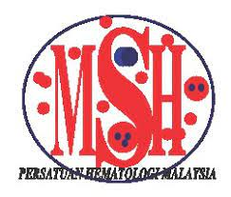

I would like to thank the Malaysian Society of Haematology(MSH) for giving me the golden opportunity to participate in the virtually conducted Highlights of ASH that was made available from 1st March 2021- 2nd April 2021.
It was indeed a great learning opportunity in difficult times like this. As a first year Haematology trainee, this virtual session has really helped me understand the latest updates in haematology practise and the latest treatment available.
Amongst the topics that drew my attention and was an eye-opener from the haemato-oncology lectures were the the novel treatments in AML and the results of the VIALE-A trial .The approach to detection and management of smoldering myeloma was indeed something I am looking forward to do in my clinical practice. The discussion on changes in management of chronic Lymphocytic Leukemia and the relevance of deep response in CLL was also very interesting and insightful.
The updates on COVID-19 thrombosis and its effect on the haemostasis was also relevant as we are frequently being referred such cases.
The updates on new medications in treatment of polycythemia and the updates on the Mediterranean diseases like Thalassemia which we deal with a lot in Malaysia and also Sickle-cell disease was very informative.
I have definitely learned a lot from attending the virtual Highlights of ASH 2021 and would like to extend my gratitude to the Malaysian Society of Haematology for sponsoring me.
Thank you MSH once again.

Sincerely,

Khaiteri
Haematology Trainee,
Queen Elizabeth Hospital,
Sabah.

