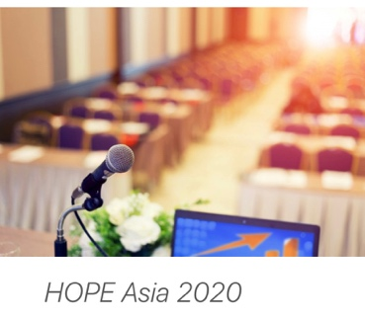
Highlights of Past EHA (HOPE) ASIA 2020: Virtual Conference

Colombo Sri Lanka
16th – 17th October 2020

The second edition of the Highlights of Past EHA (HOPE) Asia was held recently in Colombo Sri Lanka, organized with the Sri Lanka College of Haematologists (SLCH) following the successful events in Kolkata last year. The conference was held via virtual platform due to the rise of COVID-19 infections in Sri Lanka and worldwide. HOPE Asia 2020 features selected important education and scientific sessions from the 25th Congress of EHA. I am grateful and honoured to be able to attend the meetings although via virtual. It was such an eye opener as the meeting covers very important topic tailored to the needs of local haematologist. The main topics covered include bone marrow failures, bone marrow transplantation, haemophilia, immune thrombocytopenic purpura, myeloproliferative neoplasms, morphology, multiple myelomas, thrombosis and DOACs and thrombophilia (See Table 1). Most of the speakers were from Sri Lanka, India and some from Europe countries.

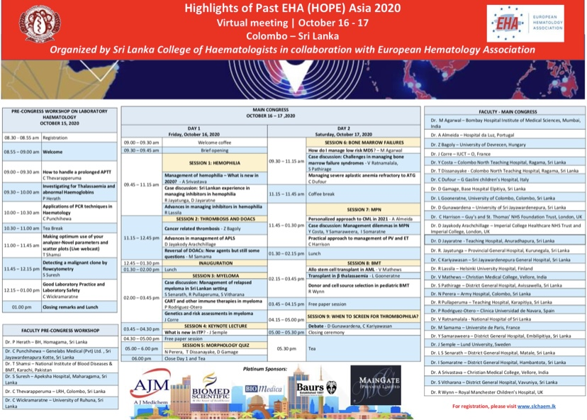
Table 1: Pre congress and Congress virtual schedule

The pre congress workshop was held one day before the meeting (15th October 2020) and it covers mostly on the laboratory aspect of hematology, including coagulation (prolonged PT/APTT), hemoglobinopathies and molecular studies. The session was very fruitful as I could revise on some aspects of laboratory hematology and its’ importance in clinical practice for example prolonged APTT could be spurious as result from underfilling of tube, heparin contamination, difficult venepuncture, delay in transport and so on.
The first day of congress covers important topics in hemophilia, multiple myeloma, thrombosis and use of DOACs. There were case studies shared during the presentation which allowed further discussion on the topics that were presented, integrating with the latest research and local data (Sri Lanka and India). At the end of 1st day of congress, I managed to grab the opportunity to participate with the morphology quiz. The quiz was quite challenging, and I gained plenty of knowledge from this session.

On the second day of congress, I was particularly interested with the topic “Managing SAA Refractory to IST” by Carlo Dufour. Dr Carlo gave a very clear lecture and case examples during his talk. Unrelated donor transplant, haploidentical and cord blood transplant can be considered when there is no matched sibling donor for relapsed cases in transplant eligible patient. The use of rabbit ATG after horse ATG in relapsed cases gave higher response rates up to 70-80% at 3 months. Transplant in AML and hemoglobinopathy were covered in BMT session during the second day of congress. There were cases shared during the session and it was very interesting discussion.

Although I was hoping to be able to attend the congress physically, this virtual congress however allowed more participants to join such important event. Lastly but not least, attending the HOPE Asia 2020 was a very fruitful and meaningful meeting to me. I would like to express my gratitude to SLCH and MSH for sponsoring me to attend this important meeting. I am truly grateful for the opportunity to attend this event and hopefully I can get opportunity to attend similar educational meetings in the future.

Prepared by
Dr Gilbert Wilfred
Hematology Trainee
Ampang Hospital
15/11/2020

