This is my great pleasure to attend The 81st Annual Meeting of the Japanese Society of Hematology, with the theme name of The Future is Now ― A Fascinating Era for Hematology. This event was held from October 11 - 13 , 2019 in Tokyo International Forum. I was impressed and fascinated by the theme word “夢(yume)” in the 81st annual meeting poster. The red ball in the middle of “夢” in the poster is meant to represent a red blood cell. A simple word yet carried a meaningful message to us, “The future does not simply come to us, but is the result of what we do today. Every one of us should keep this in mind, and act now in pursuit of one’s ideal future, in other words, one’s dream”.

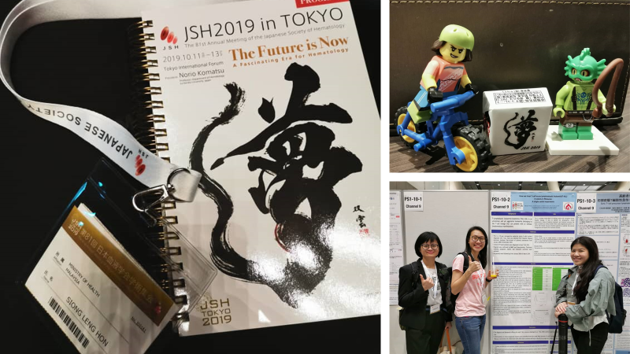

This annual meeting has a widespread cover of red cell, white cell and platelet disorders. I personally feel that this meeting has put more emphasize on the future perspectives of myeloproliferative neoplasms. Other than this, this meeting has included ASH and EHA presidential lectures, Joint Symposiums with ASH and EHA, and Asian Joint Panel Discussion as well. It was my honor too to present my poster “How we treat T-cell acute lymphoblastic leukemia(T-ALL) in adults in Hospital Ampang” in this meaningful annual meeting.
I did have the "pleasure" to witness Typhoon Hagibis 2019 and experience the feel of earthquake on my second stay in Tokyo. On 12 October, Hagibis made landfall at Izu Peninsula as a Category 2–equivalent typhoon. Few international matches being cancelled, public transports and supermarkets announced to suspend or minimize operation on that day. Residents stocked up on water, food and other supplies, leaving many supermarket shelves empty. 5 of us were being quarantined in the hotel, and waiting patiently for this crisis to be over. We were lucky as this typhoon didn’t bring strong winds and heavy rainfall to the area we stayed. We sailed through the crisis without much adrenaline rush. Most services were resumed the next day and 5 of us able to fly back Malaysia unharmed.

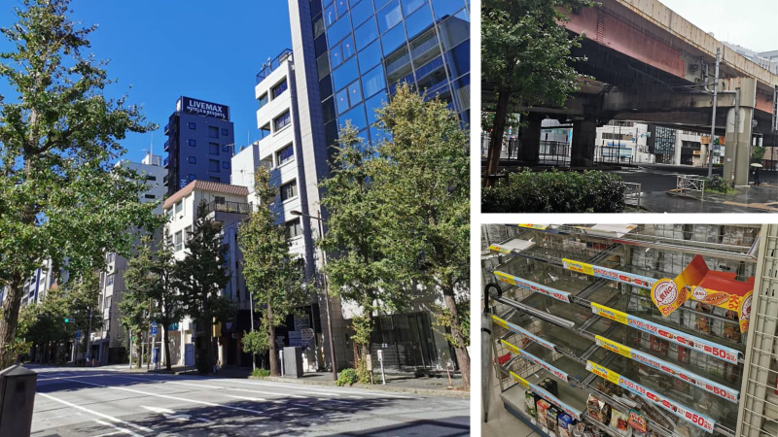

In short, even I can't attend the full 3 days course because of the natural disaster, this is a highly academic and fruitful annual meeting, with expert opinion and exchange information from the well known speakers from different countries.

Report prepared by
Hon Siong Leng
2nd November 20119

