EVENT : 81st Annual Scientific Meeting Japanese Society Haematology 2019

LOCATION : Tokyo International Forum, Tokyo, Japan

DATE : 11th – 13th Oct 2019

TRAINEE : Frances Leow May Yan

First and foremost, I would like to extend my gratitude to MSH for the grant provided to attend this conference. This grand meeting was attended by more than 800 speakers and delegates from all around the world. The main theme of this annual meeting was “ The Future is Now – A Fascinating Era for Haematology”. Majority of the talks were in Japanese. Some of the highlights during this conference which were conducted in English include:
- Cellular recycling by autophagy – lessons from yeast; Yoshinori Ohsumi, 2016 Noble Prize in Physiology/ Medicine awardee, Japan.
- High risk JAK/STAT driven ALL lessons from Down syndrome; Dr. Shai Israeli, Israel.
- Testing novel and targeted therapies in children, adolescents and young adults with ALL; Stephen P. Hunder, USA.
- Inherited bone marrow failure; Jean Soulier, France.
- Clinical and genetic heterogeneity of GATA2 and SAMD9/9L syndromes predisposing to MDS; Marcin W. Wlodarski, USA.
- JSH-ASH Joint Symposium: Recent Advances in Translational and Clinical Research in Lymphoid Malignancies - Update on secondary CNS relapse in DLBCL: Who is “high risk”? Optimal prophylaxis?; Kerry J. Savage, Canada
- Progress and challenges for immune checkpoint blockade in haematologic malignancies; Alexander M. Lesokhin, USA.
I am privileged and honoured to present our Malaysian real-world experience on “Retrospective observational analysis of DA-EPOCH-Rituximab chemotherapy in untreated high-risk DLBCL”.
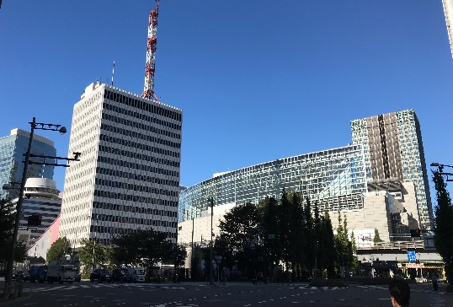
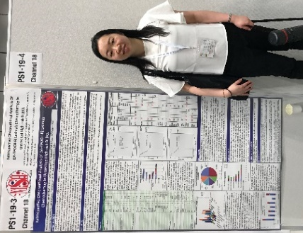
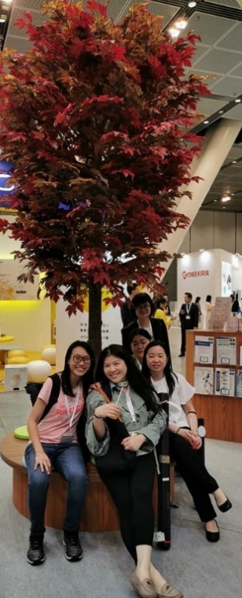
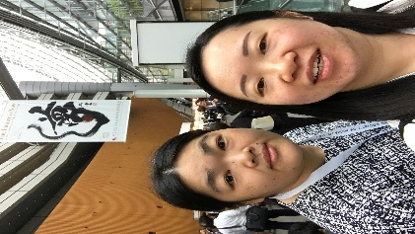

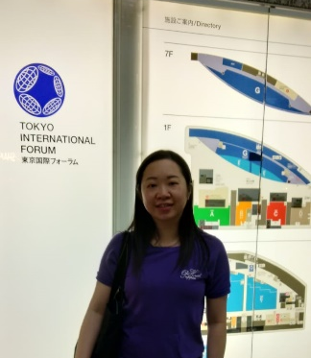
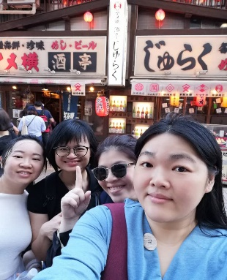
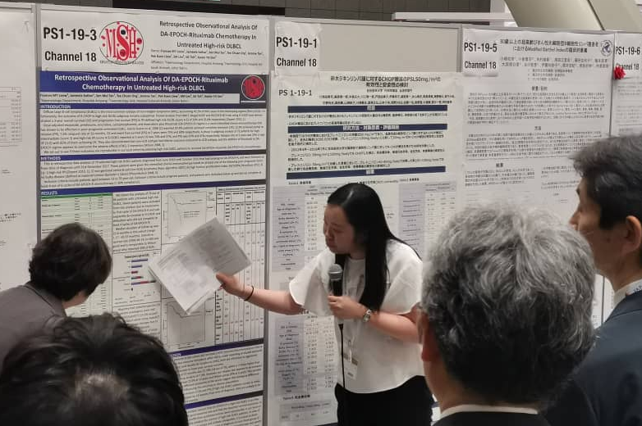

Our conference was cut short by Typhoon Hagibis, which was predicted to be the worst typhoon ever experienced by Japan and human history with raging wind speed up to 260km/h. Co-incidentally there was also earthquake 5.9 Richter scale in Tokyo on 12th October 2019. We were stranded in the hotel, and strongly advised by conference and hotel staff not to leave the hotel premise for our safety. We stocked up on food and cup noodles but most of the shelves at supermarkets and convenient stores were practically empty by the time we got to it. The aftermath caused at least 77 fatalities and more than USD$9 billion damages.
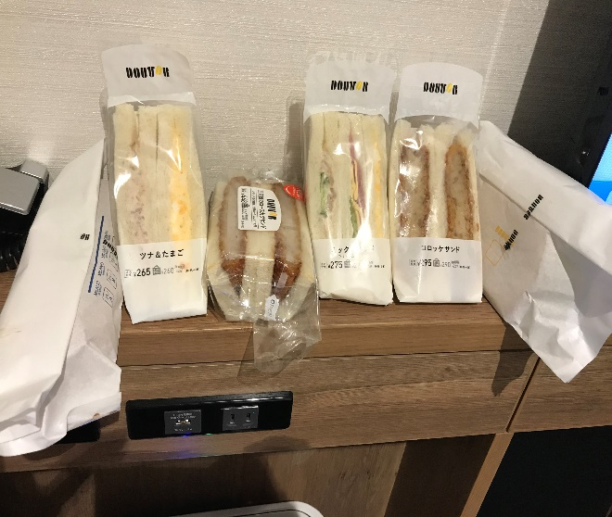

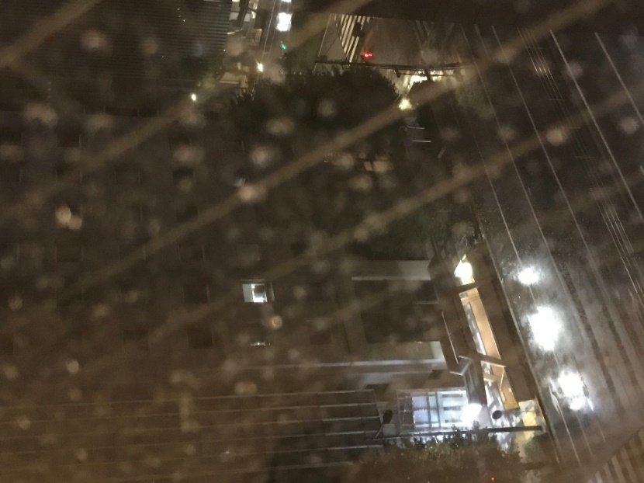
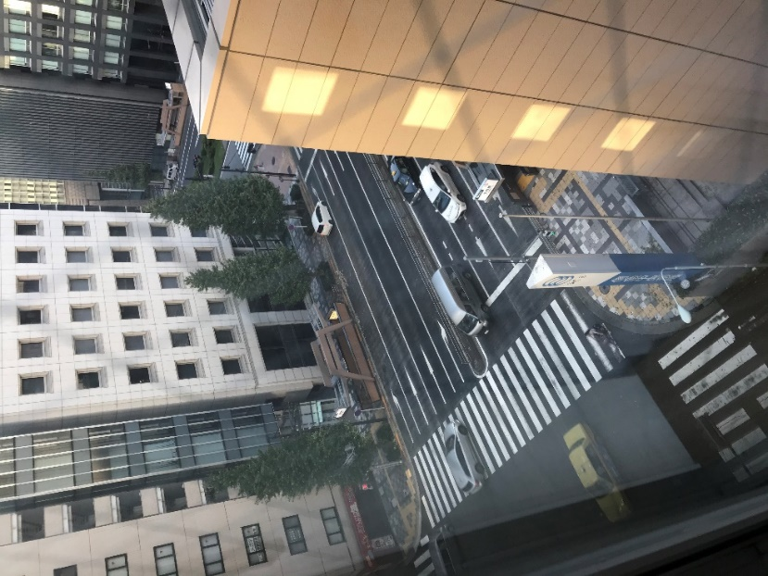

All 5 delegates from Malaysia were fortunate to be safe and unharmed by this natural disaster. It was an unforgettable, lifetime experience for all of us. We are grateful to return back to Malaysia and our home sweet home.

Report prepared by,
Frances Leow

