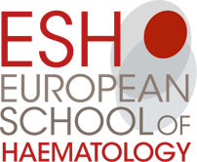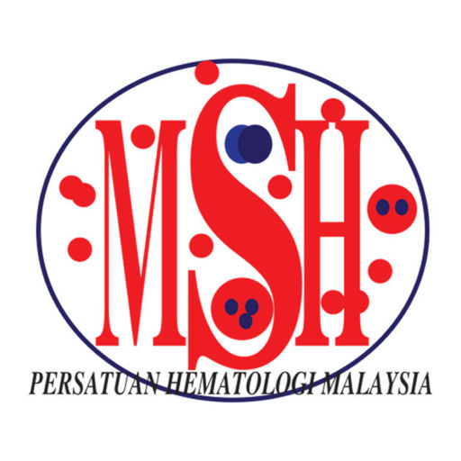
4th International Conference on Multiple Myeloma (5-7th October 2018)
Venue : Mandelieu , France
I was recently given the privilege to attend the above mentioned conference and also to present a poster and what an experience it was.
The event was chaired by renowned Myeloma experts e.g. Philippe Moreau (France), Maria Victoria Mateos (Spain), Kenneth Anderson (US) and was graced by many more. The focus of the conference was mainly on updating the advances in Multiple Myeloma and other plasma cell related disorders.
First Day (5th October 2018)
The 1st day started off with a session on Smouldering Myeloma (SMM), with the focus on identifying parameters that define high risk SMM, how monitoring of SMM should be done and also the current clinical trials ongoing to demonstrate if there is benefit in treating SMM.
The 2nd session was on diagnosis of Multiple Myeloma. In this session, the SLIM CRAB criteria was reinforced as per IMWG criteria 2016. There was a discussion on which mode of imaging modality (WBLDCT vs MRI) in certain situations. There was a brief discussion on genetics and risk profiling and here I was introduced to the terminology of “double hit” and “triple hit” Multiple Myeloma.
The 3rd session focused on newly Diagnosed Multiple Myeloma (NDMM) in those who are not transplant eligible (NTE). A brief discussion on models of geriatric assessment and the difference in approach towards this group of patients from the European and American perspective incorporated in the ESMO and NCCN guidelines.
In the 4th session, a similar discussion on those who are transplant eligible with the additional focus on induction therapy (triple vs quadruple). We were then introduced to the exciting prospect of the possibility of cure in those who can achieve MRD negative (with a sensitivity of 10⁻⁶) or deeper for more than 5 years. The two sessions ended with debates on (Fixed duration or continuous therapy) and (single or tandem autologous transplant).
The day ended with a poster walk session, where I had the opportunity to share our local systemic light chain Amyloidosis (AL) cohort with foreign delegates.

Second Day (6th October 2018)
The 5th session resumed on the 2nd day. In this session, assessment of response was the focus. There was in depth discussion on NGF and NGS and also imaging modalities (PETCT and MRI). The session concluded with an interesting oral presentation by one of the delegates whose work on Zr89-daratumumab PET CT assessment of treatment response.
Session number 6 was allocated to those who were in relapsed / refractory setting. Here there was a topic on when and how to treat relapsed Myeloma, with particular interest on the biochemical relapsed patients who were asymptomatic. We were then given an overview on the novel treatments.
The day ended with session number 7 with immunotherapy being the main topic. Monoclonal antibodies, adoptive cell therapies, vaccine therapies and also the much discussed CAR-T with single and dual targets were presented.
Third Day (7th October 2018)
The focus was then shifted to other plasma cell related disorders in the 8th session e.g. Waldenstrom macroglobulinemia, Amyloidosis and POEMS. There was a topic in this session that discussed monoclonal gammopathy with clinical significance (MGCS) and renal significance (MGRS) .
The last session briefly discussed on clinical trials, data management, how to judge a clinical trial, with new end points and new designs for clinical trials.
I enjoyed the conference as it was my first international conference and also a very educational one.
As the conference ended at lunch time, the permissible weather allowed me to walk around the town of Mandelieu. Besides being able to ask the experts on Myeloma related questions, I made a few acquaintances during this conference and shared our clinical experience at our respective centres with each other.
I would like to thank to Malaysian Society of Haematology (MSH) for the provision of the Education Fund and European School of Haematology (ESH) for making this possible.

Sincerely,

Christopher Liam Chin Keong
Clinical Specialist in Haematology (Trainee),
Hospital Ampang,
Malaysia

